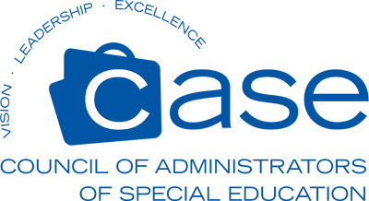
Certificate of Continuing Education Credits
NC CASE Annual Conference October 2-5, 2022 Wrightsville Beach, NC
Activity Title Date(s) Location

20 total hours or 2.0 CEUs Sandy Albert, Michael Marcela and Teresa Owens
Number of Hours / Units of Credit NCCASE Conference Co-chairs

The individual named below has successfully completed a non-college credit Professional Development activity provided by the NC Council for Administrators of Special Education (NCCASE).
Participant Name (Printed) Participant Signature

